***Task 3.2C***

***CLOUD COMPUTING***

***Creating a Dynamic Website for the Café***

**Task 1: Analyzing the existing EC2 instance**

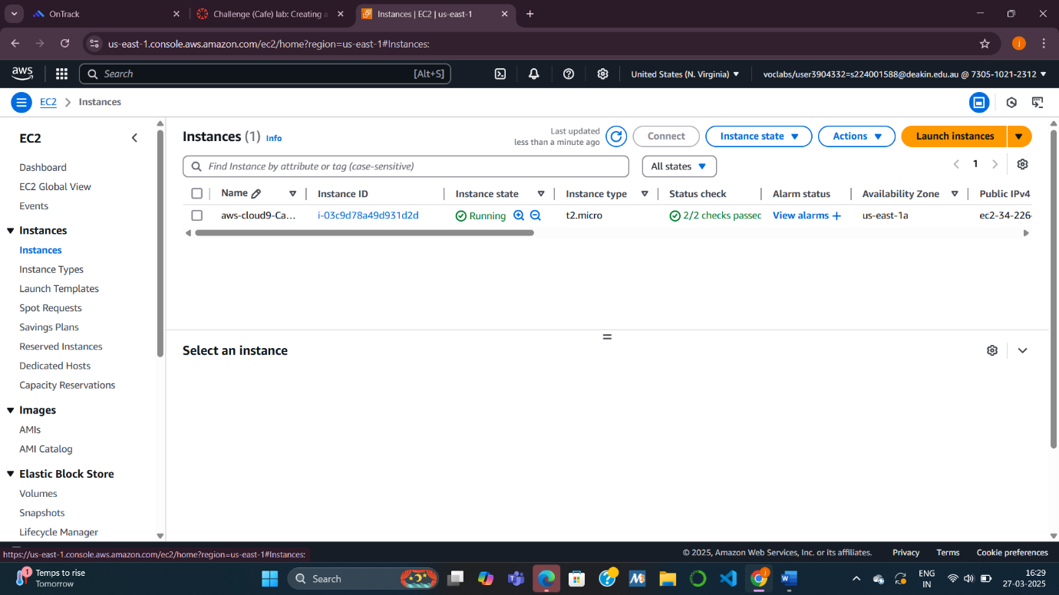

**Task 1.1: Answering questions about the instance**

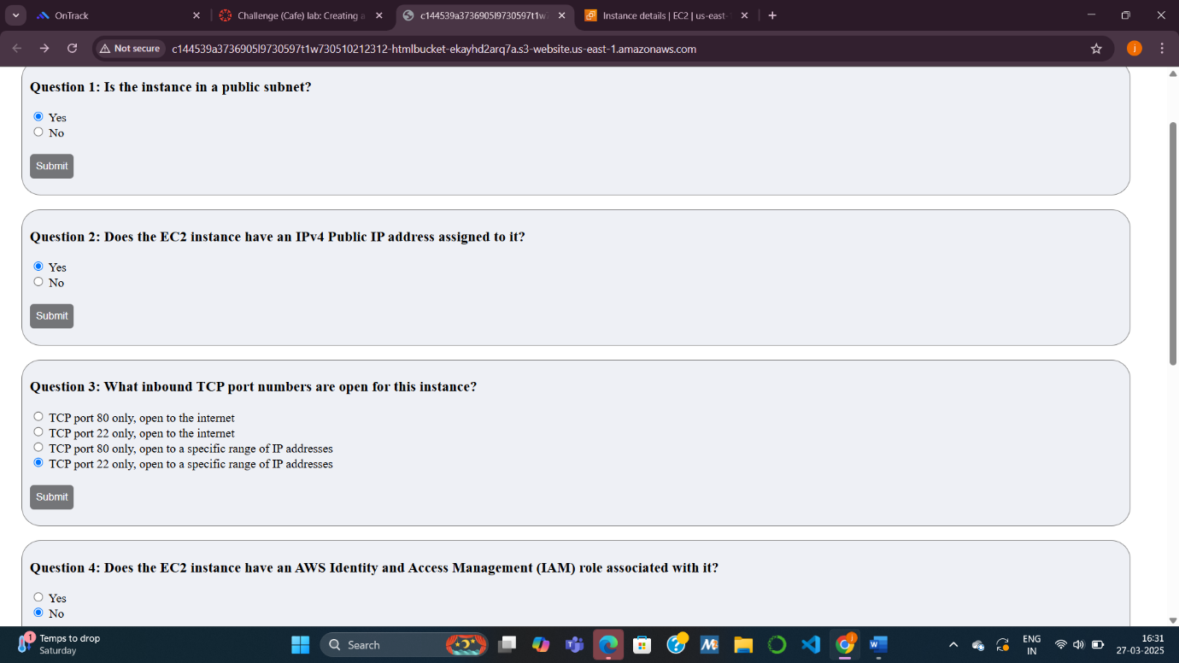

**Task 2: Connecting to the IDE on the EC2 instance**

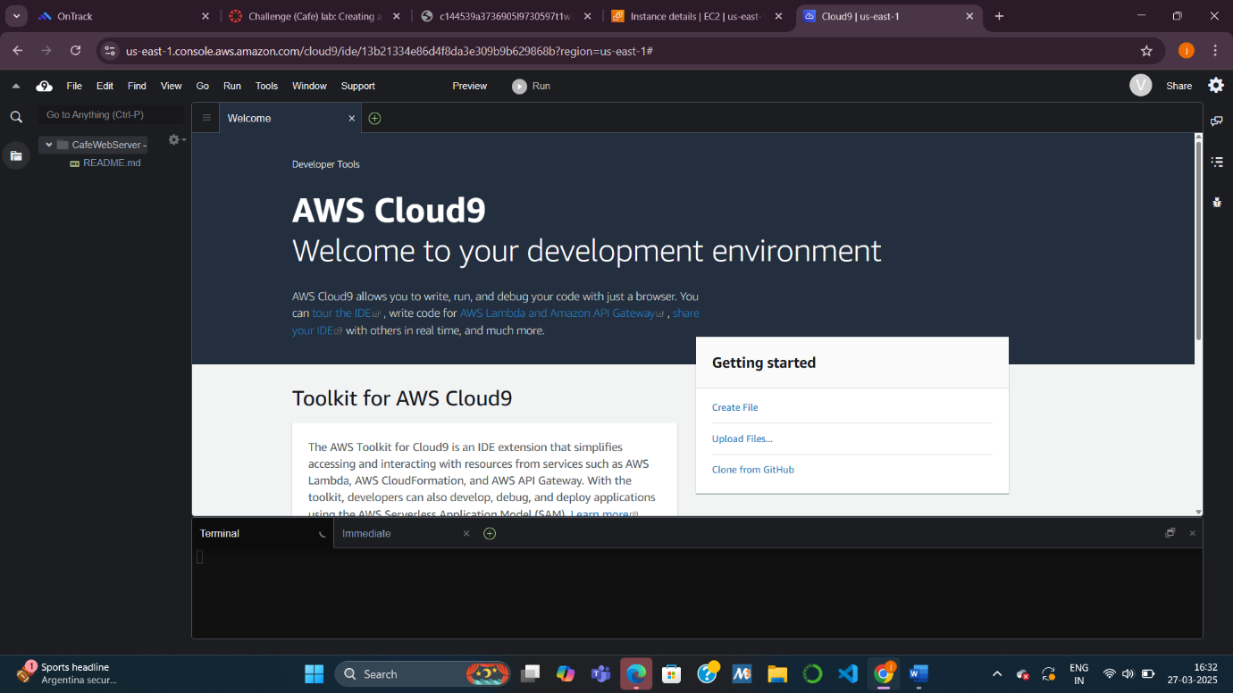

**Task 3: Analyzing the LAMP stack environment and confirming that the web server is accessible**

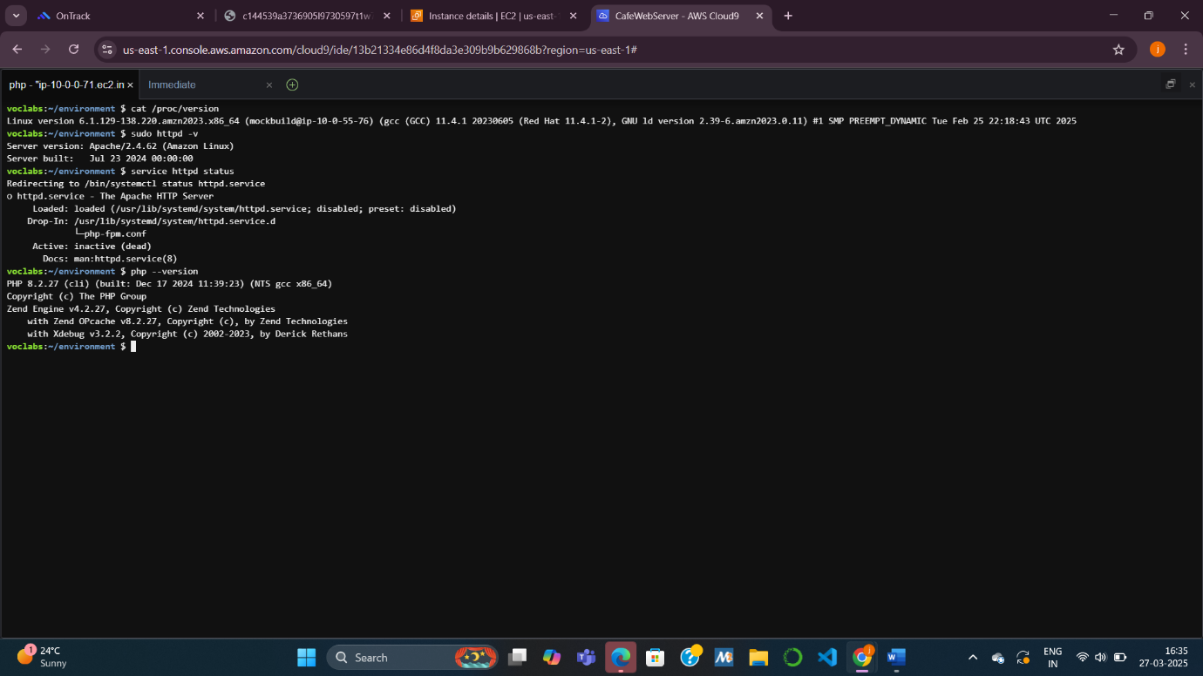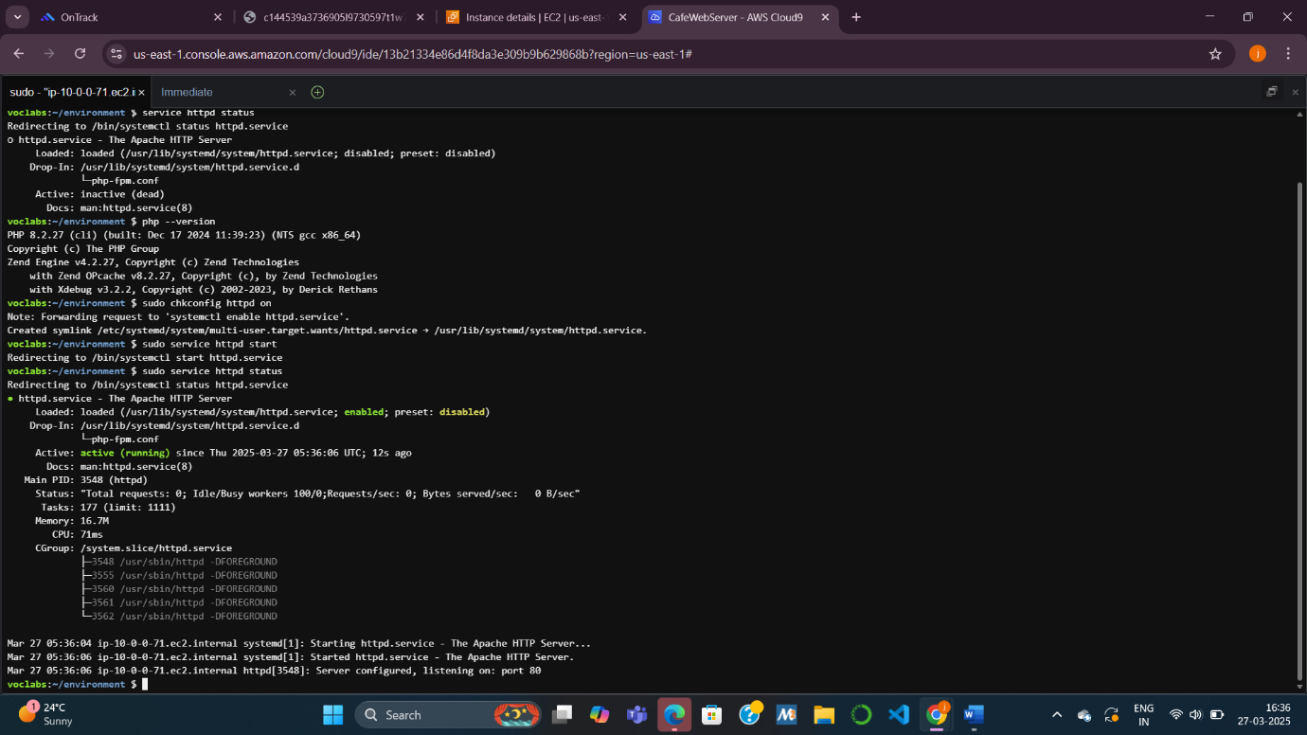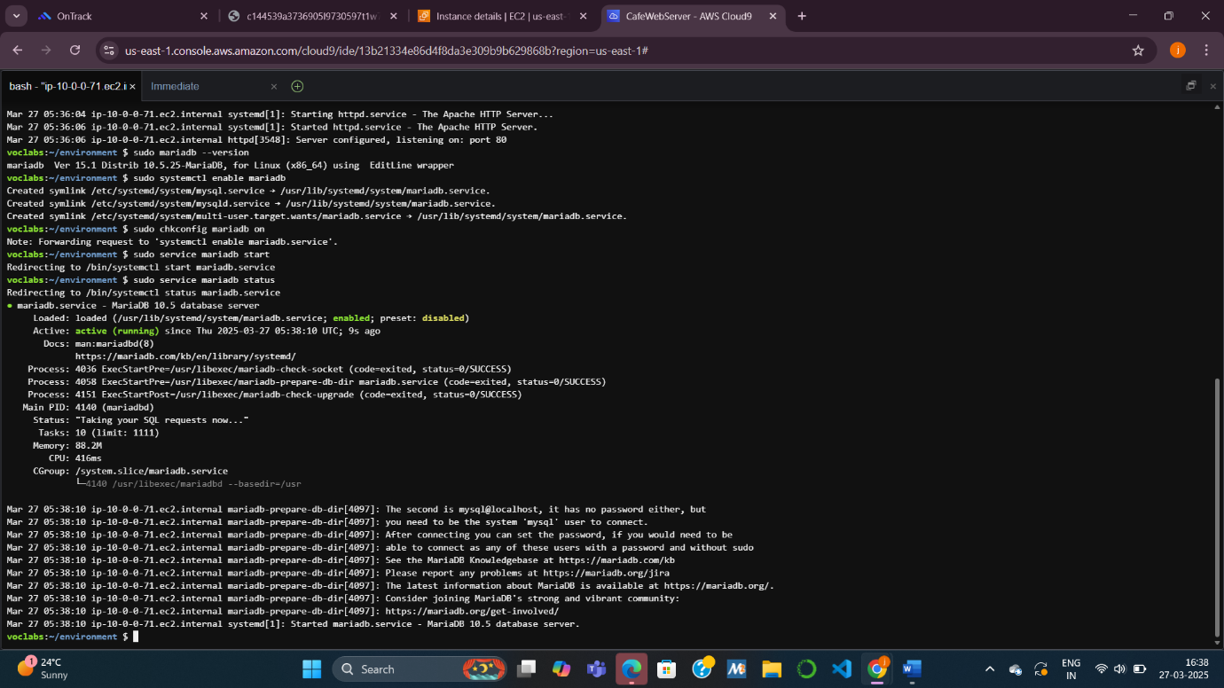

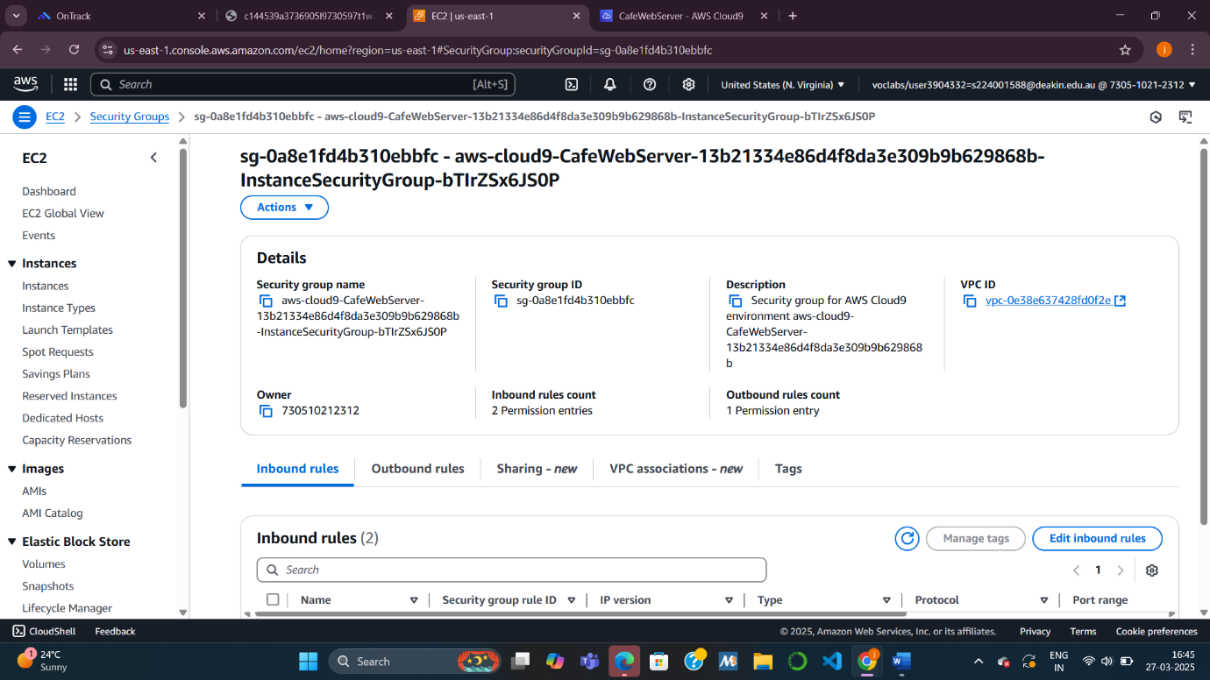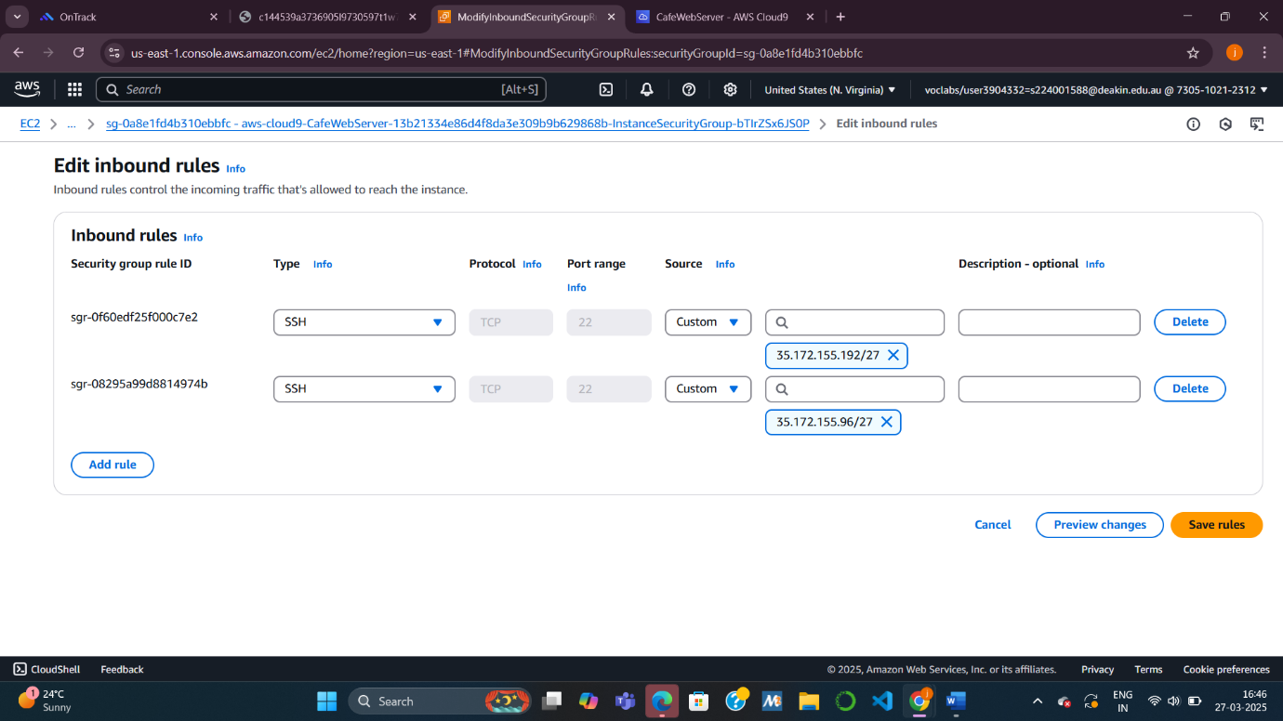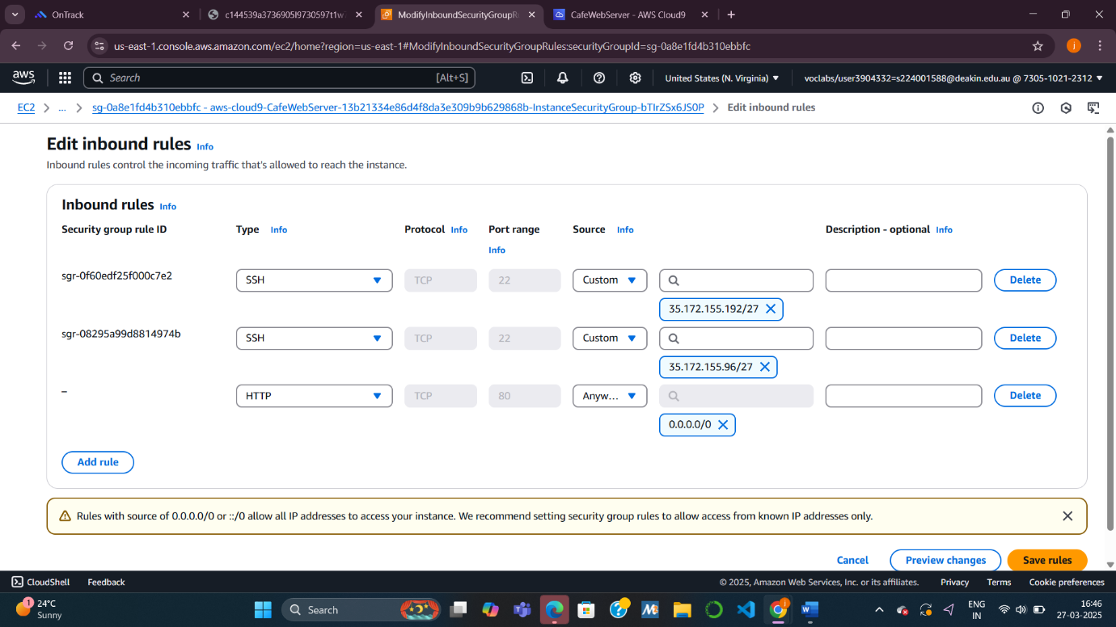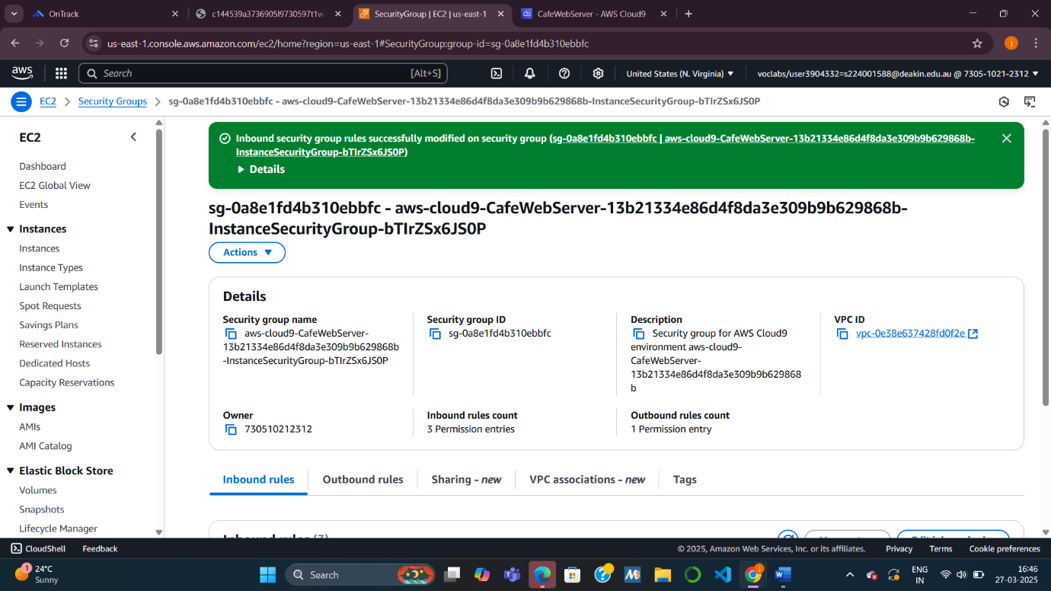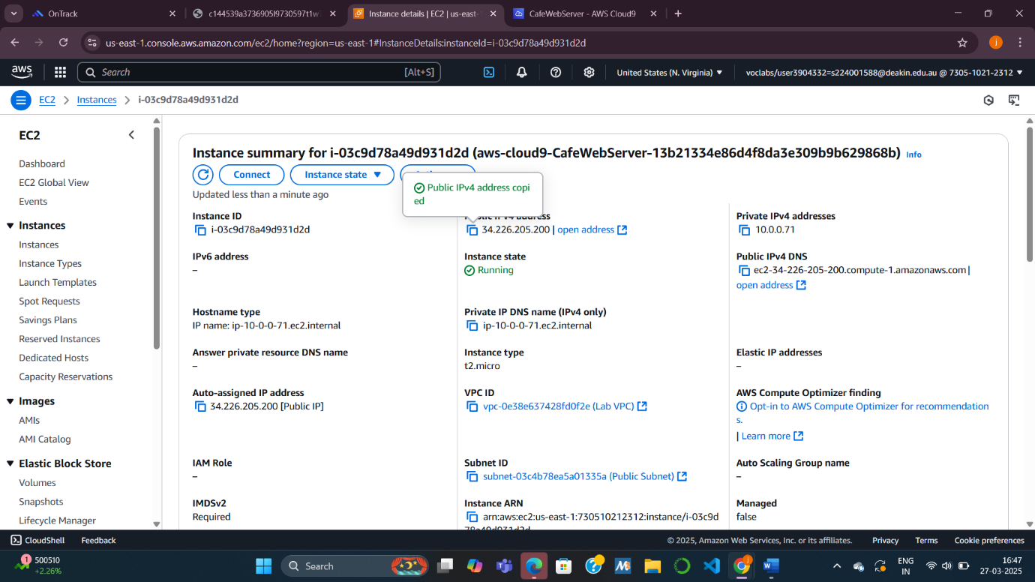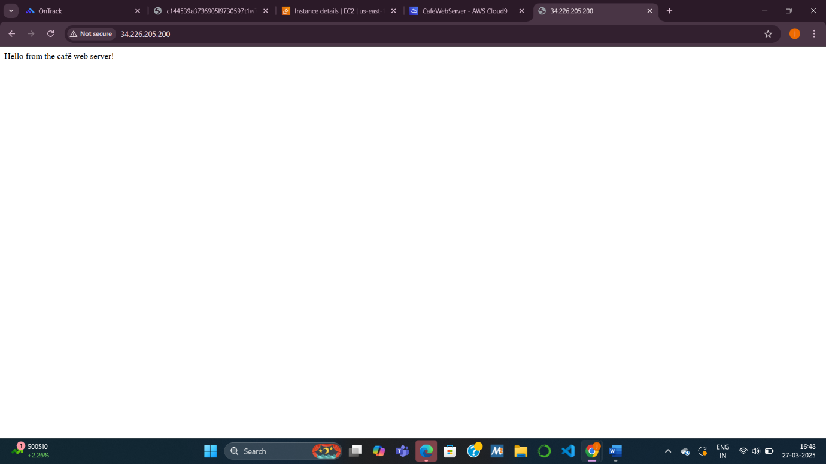

**Task 4: Installing the café application**

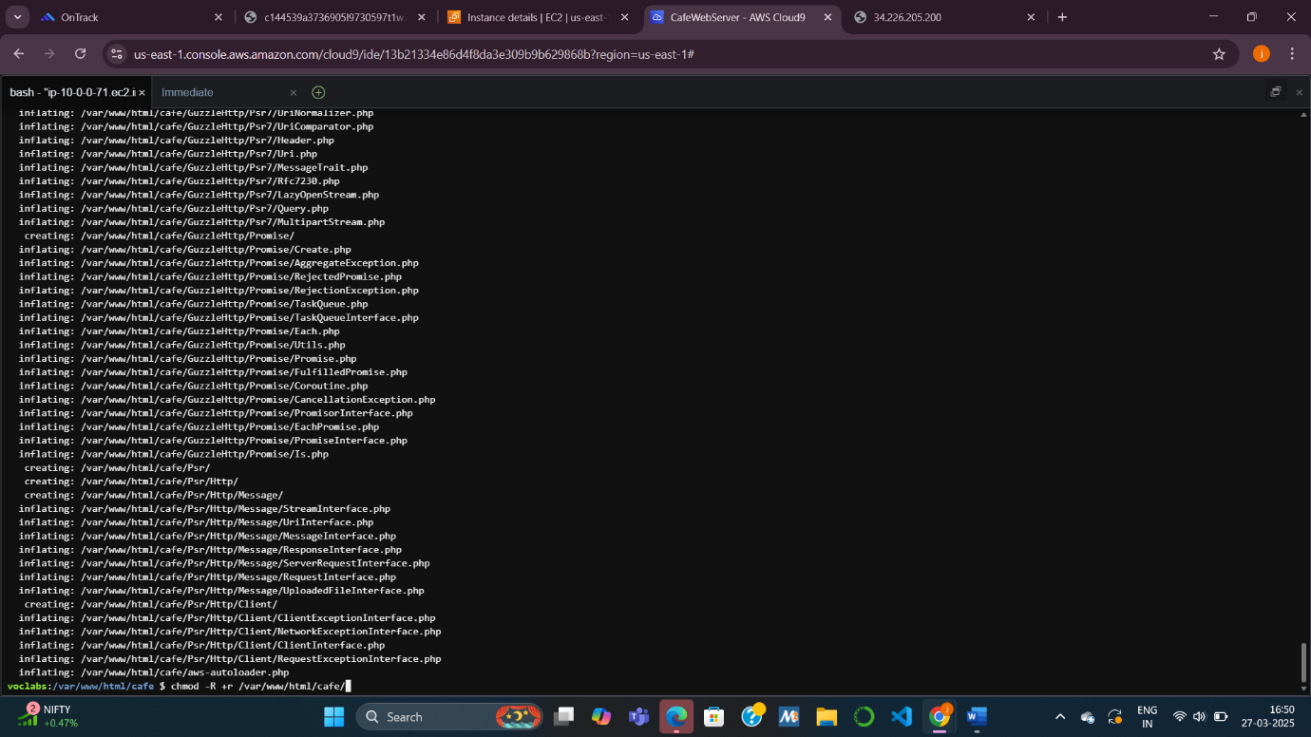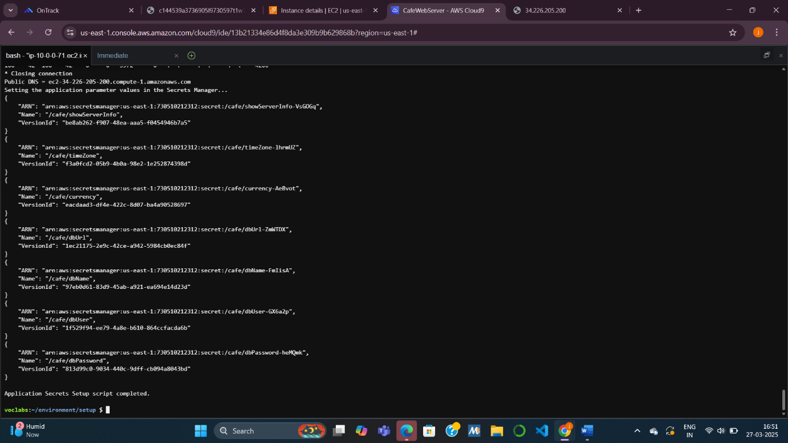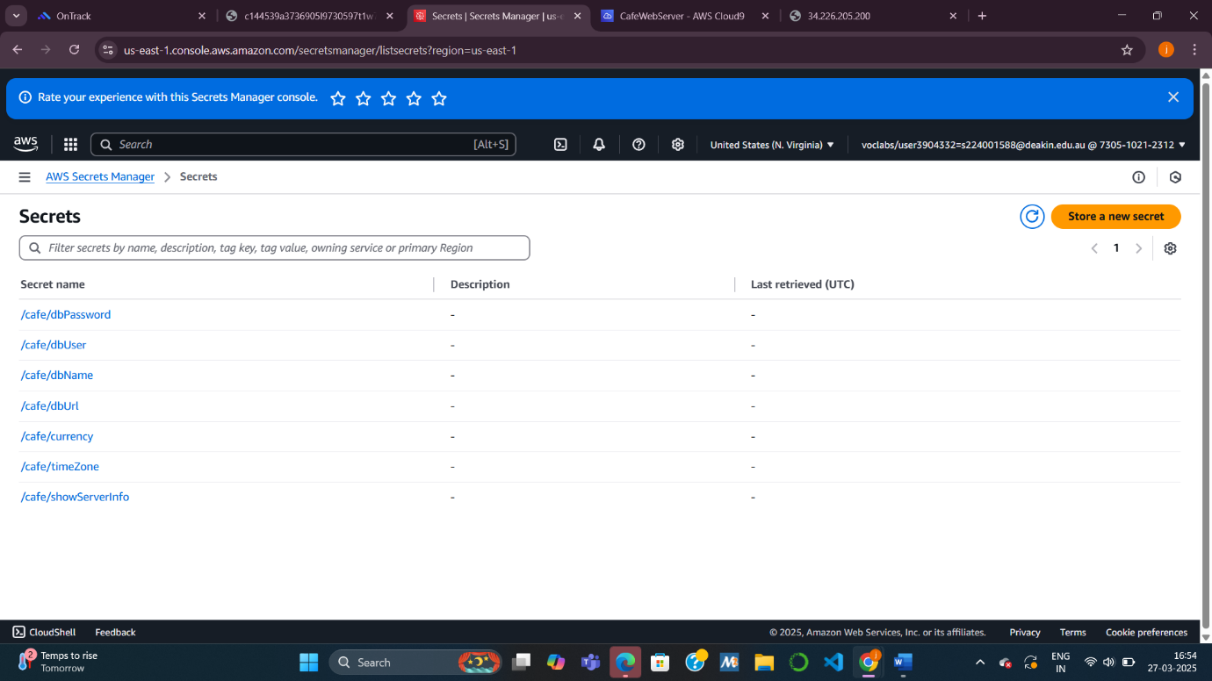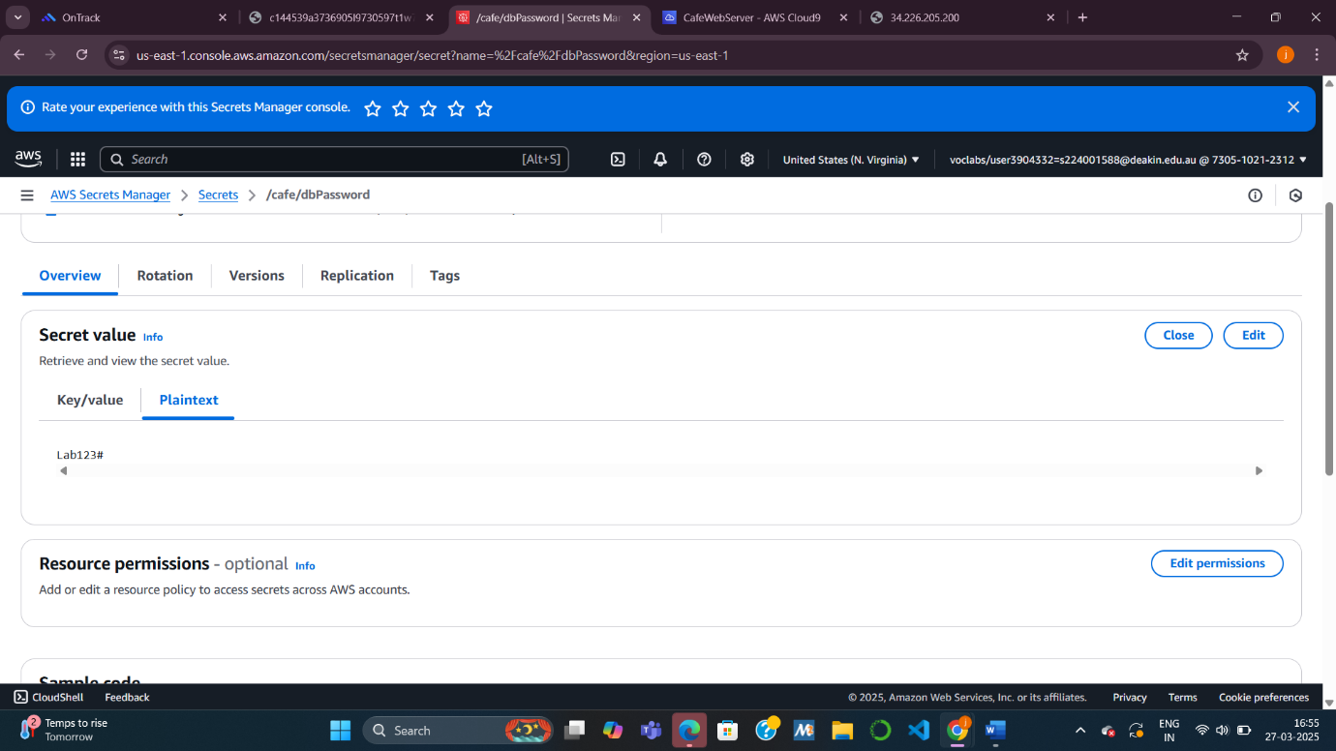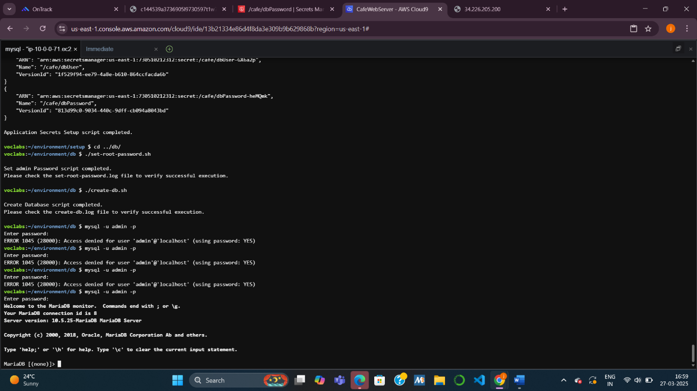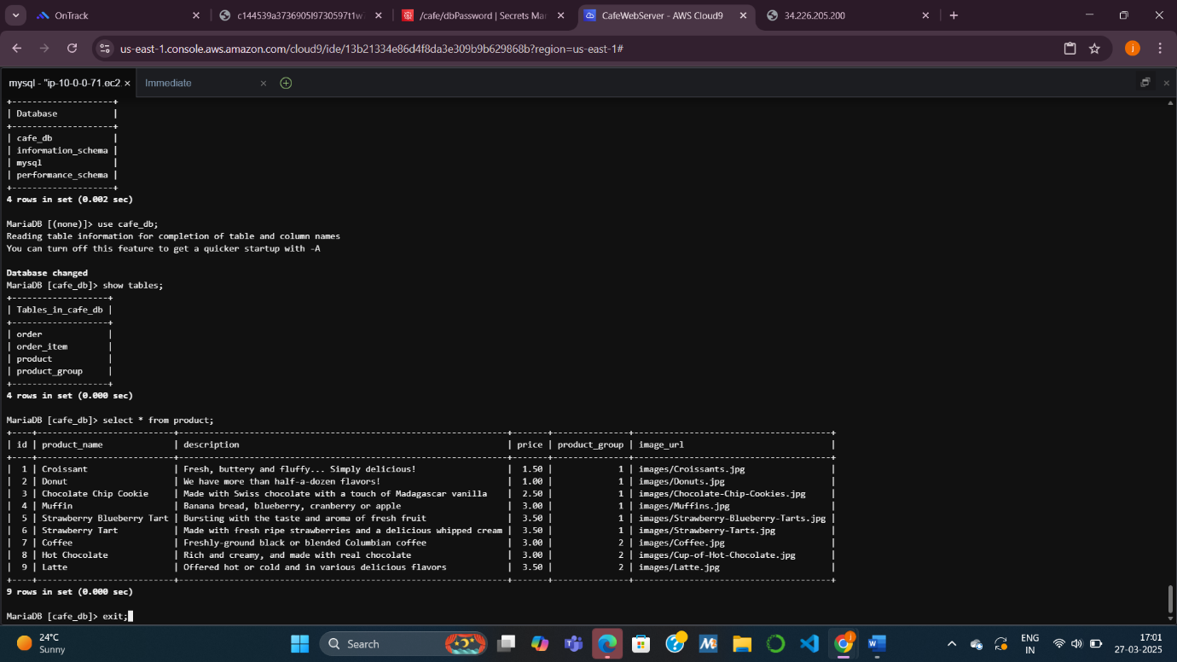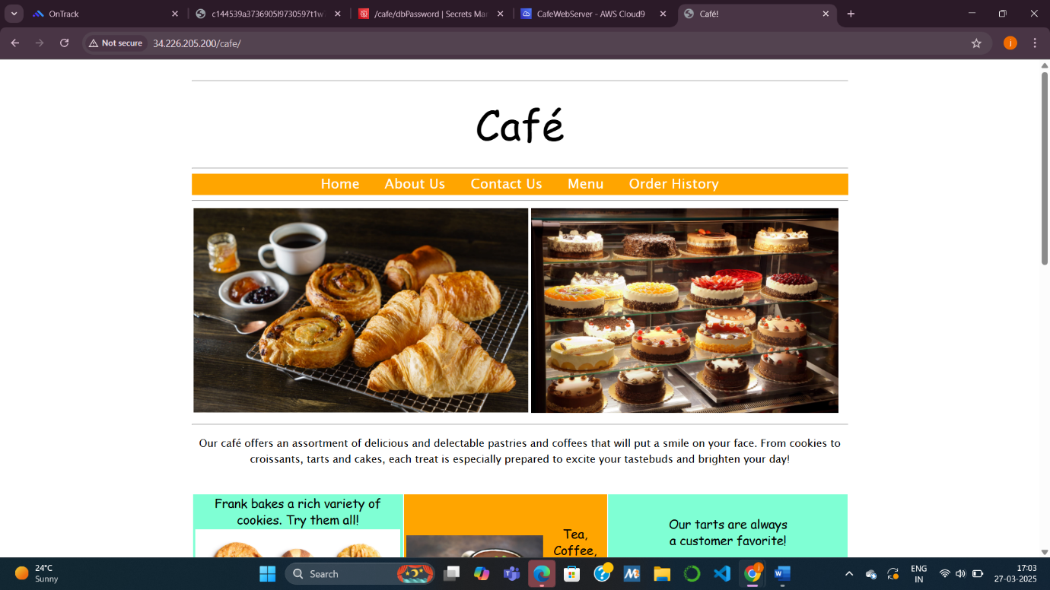

**Task 5: Testing the web application**

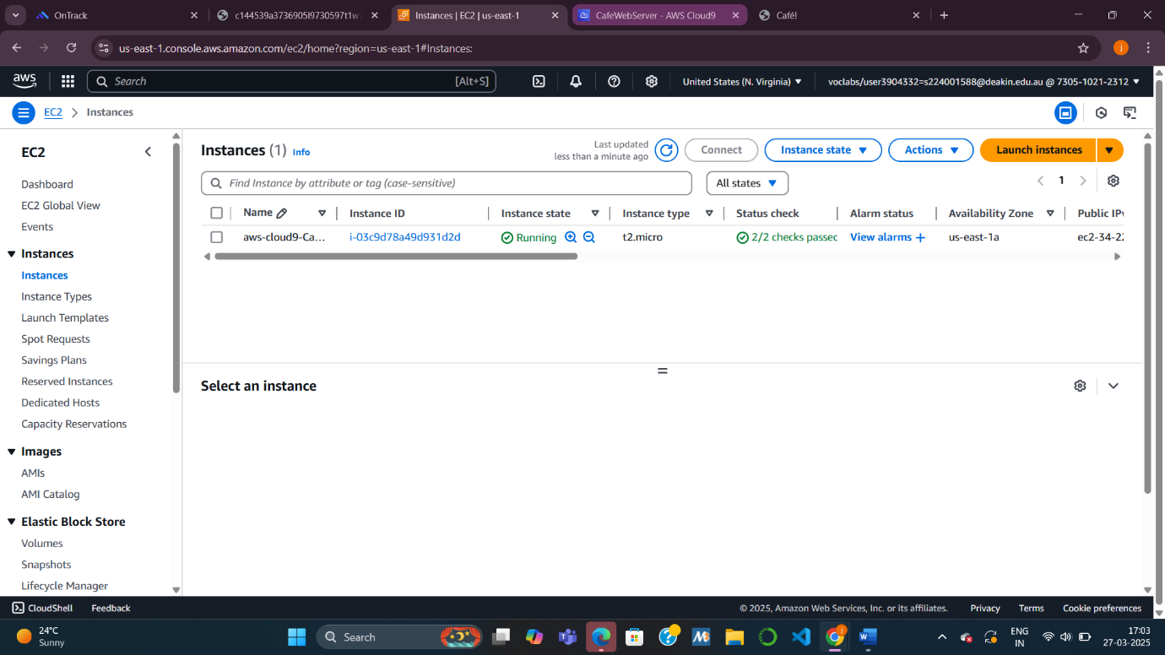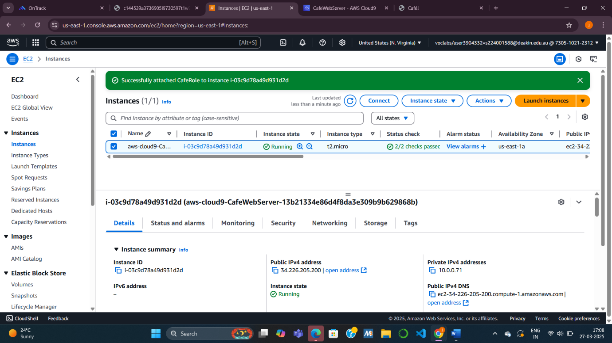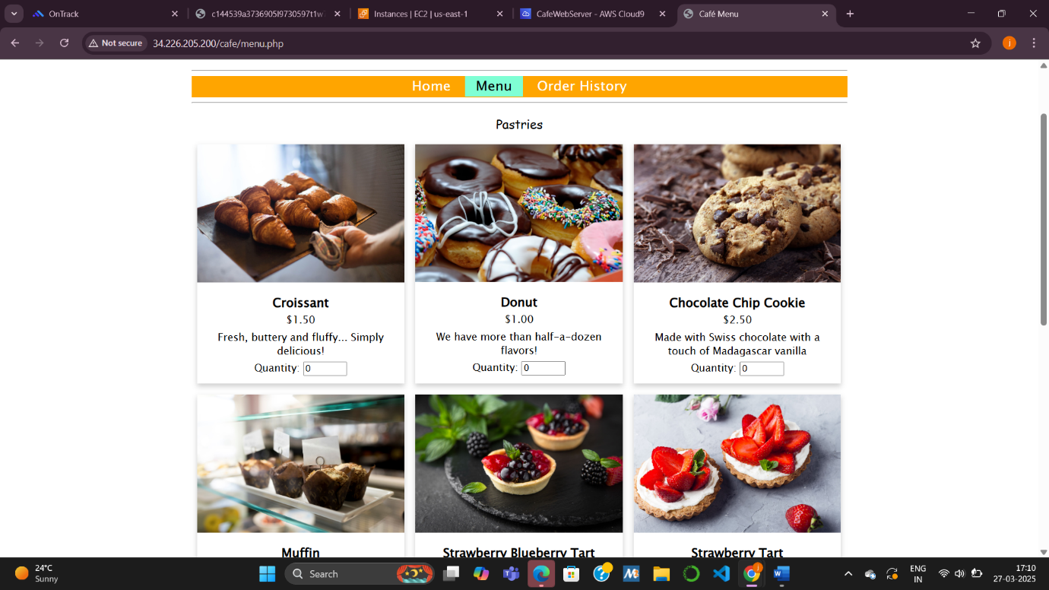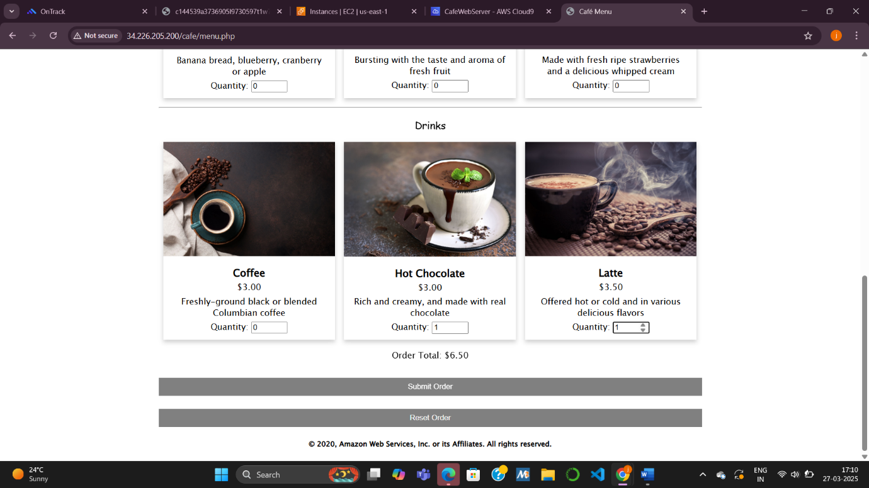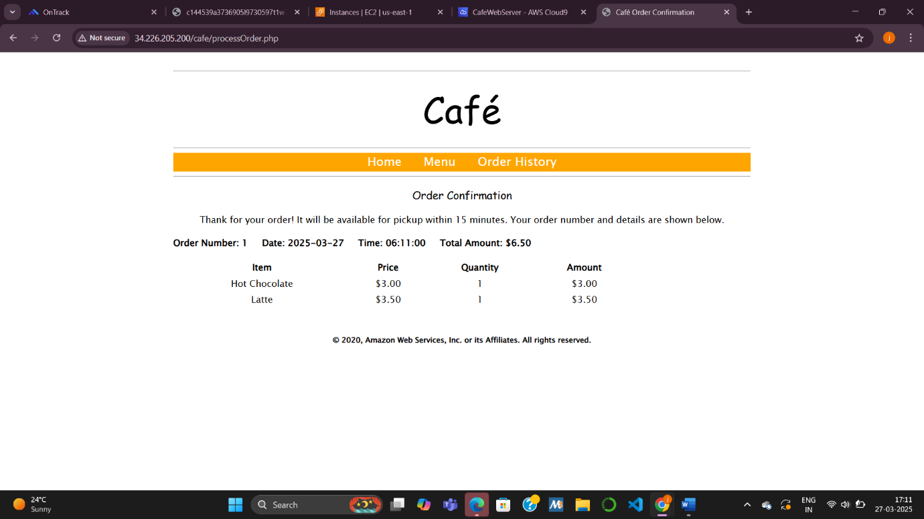

**Task 6: Creating an AMI and launching another EC2 instance**

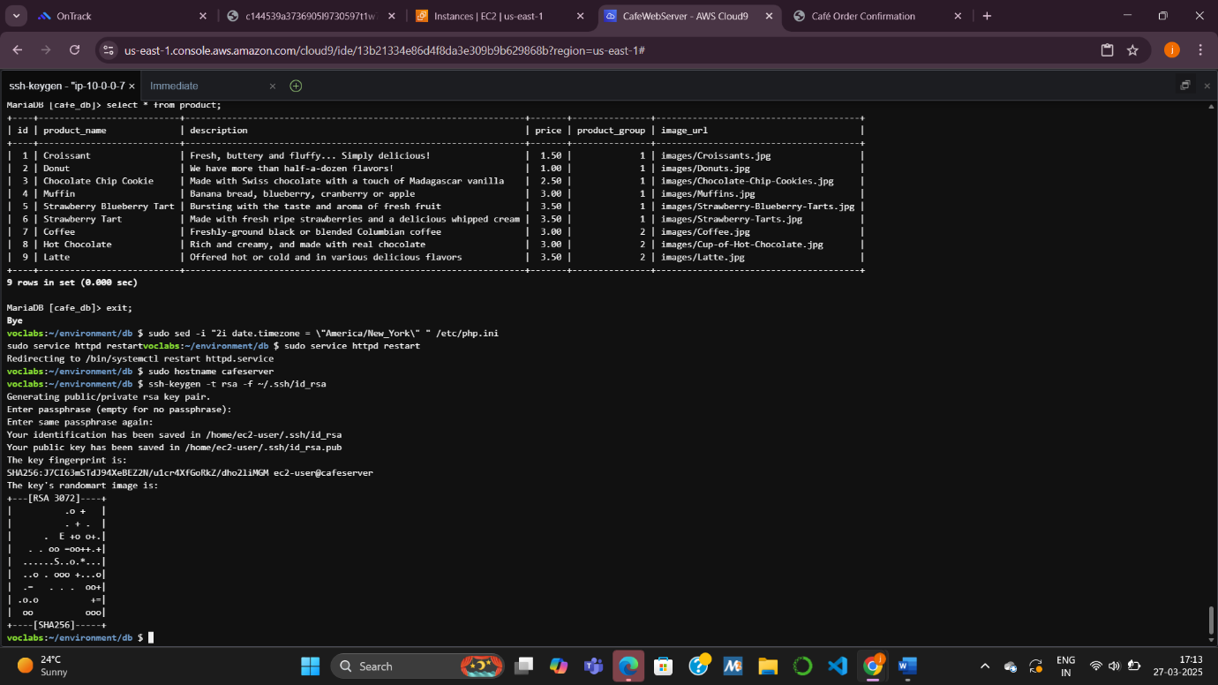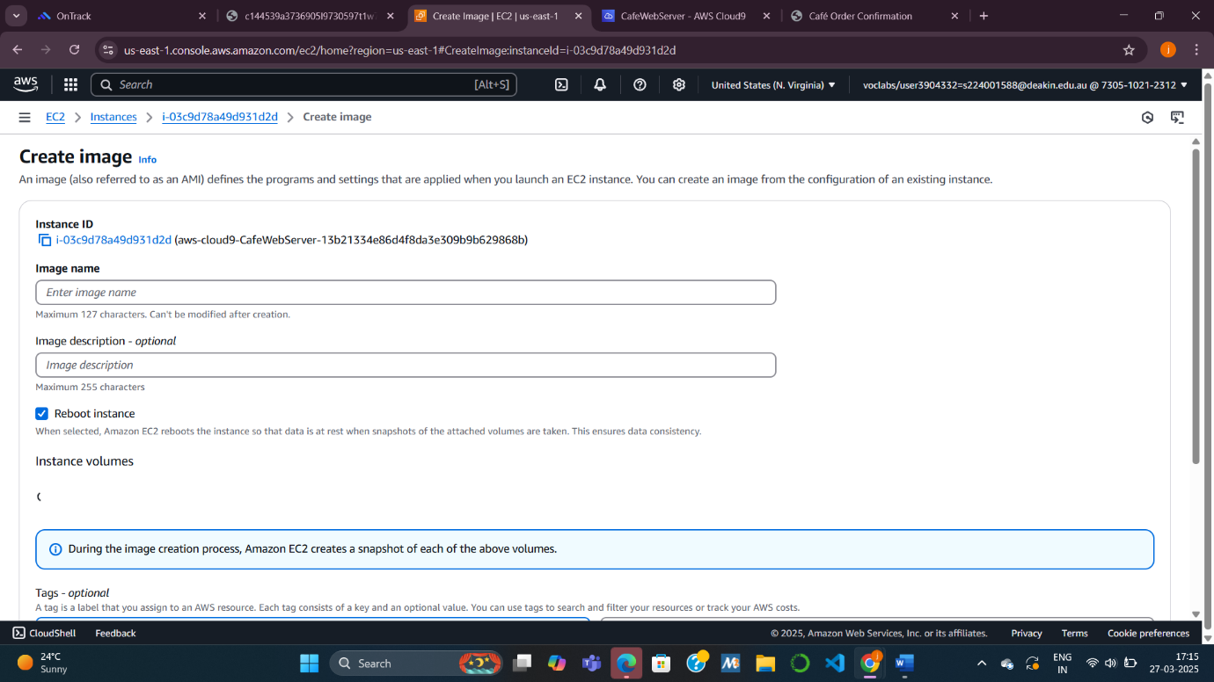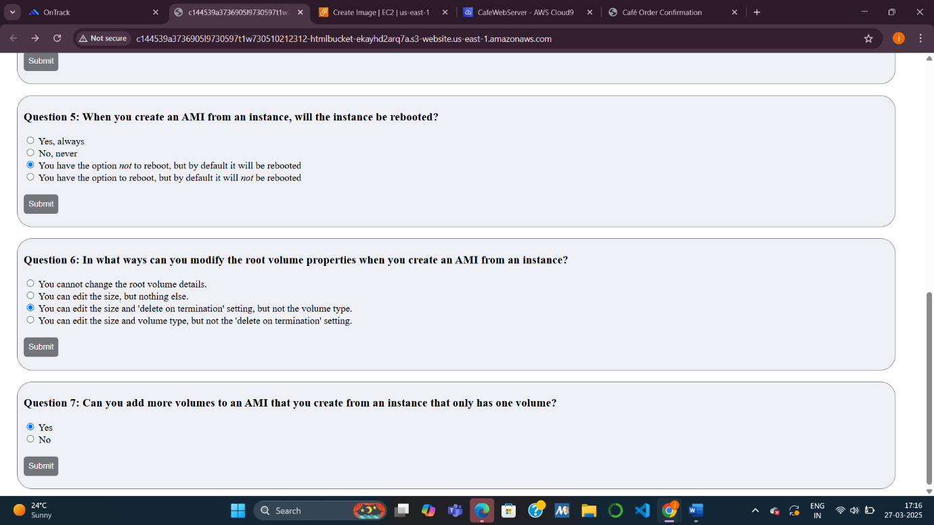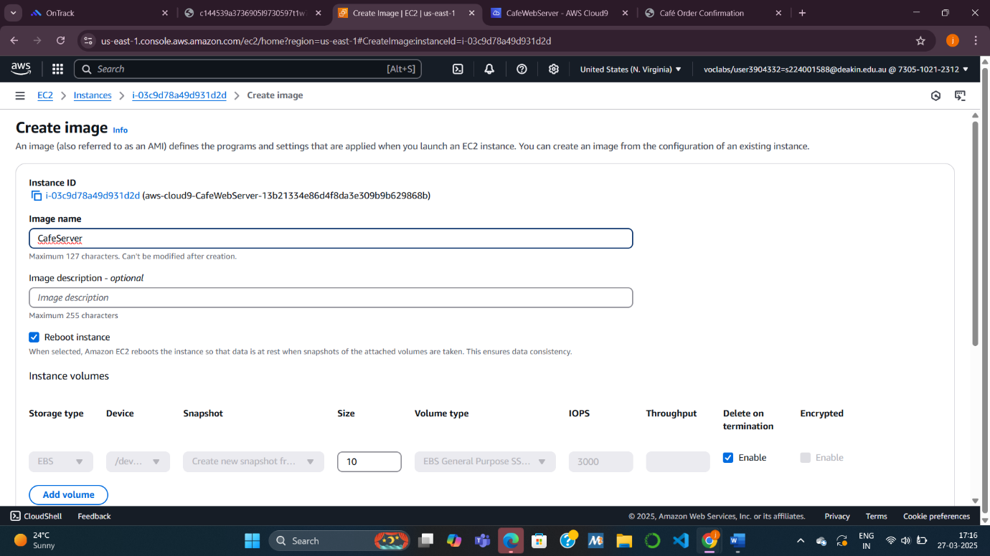

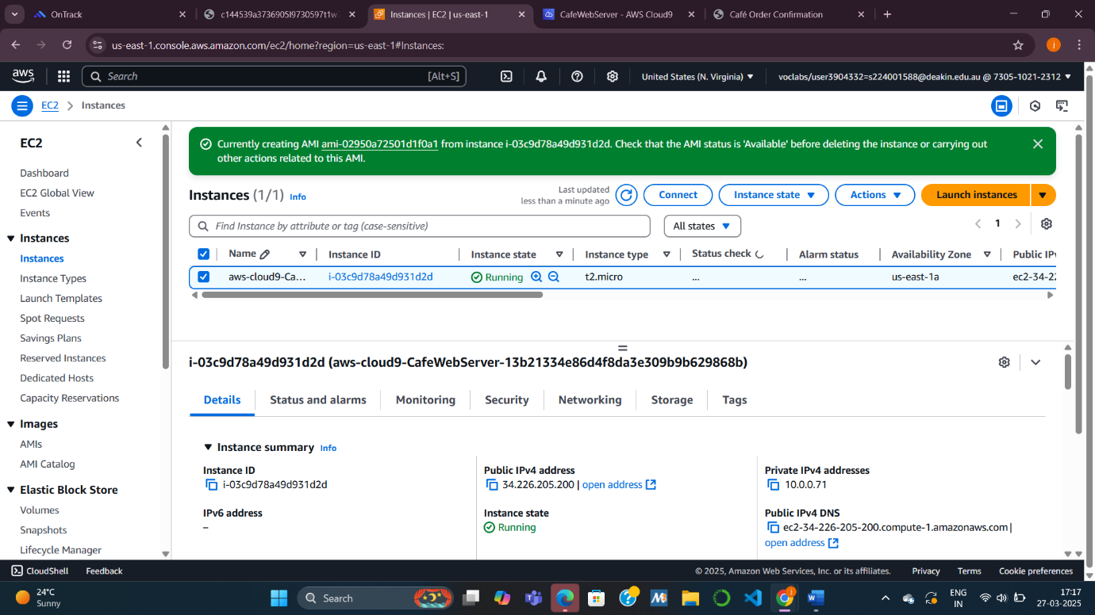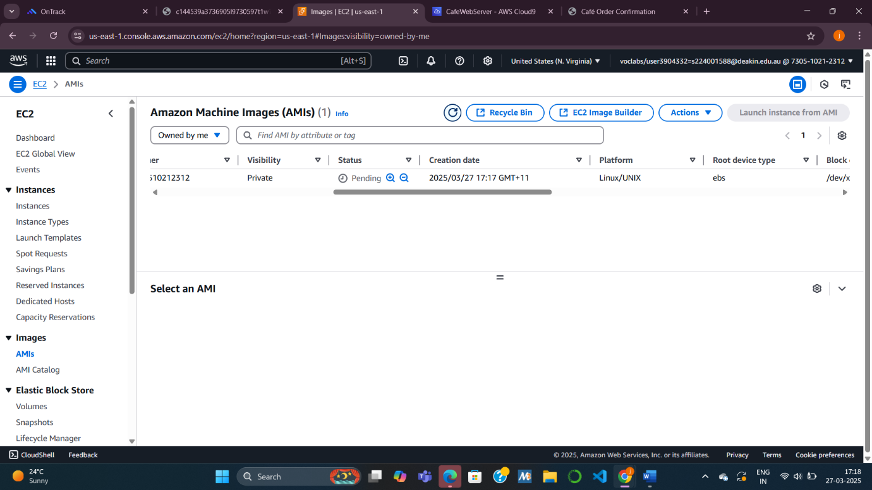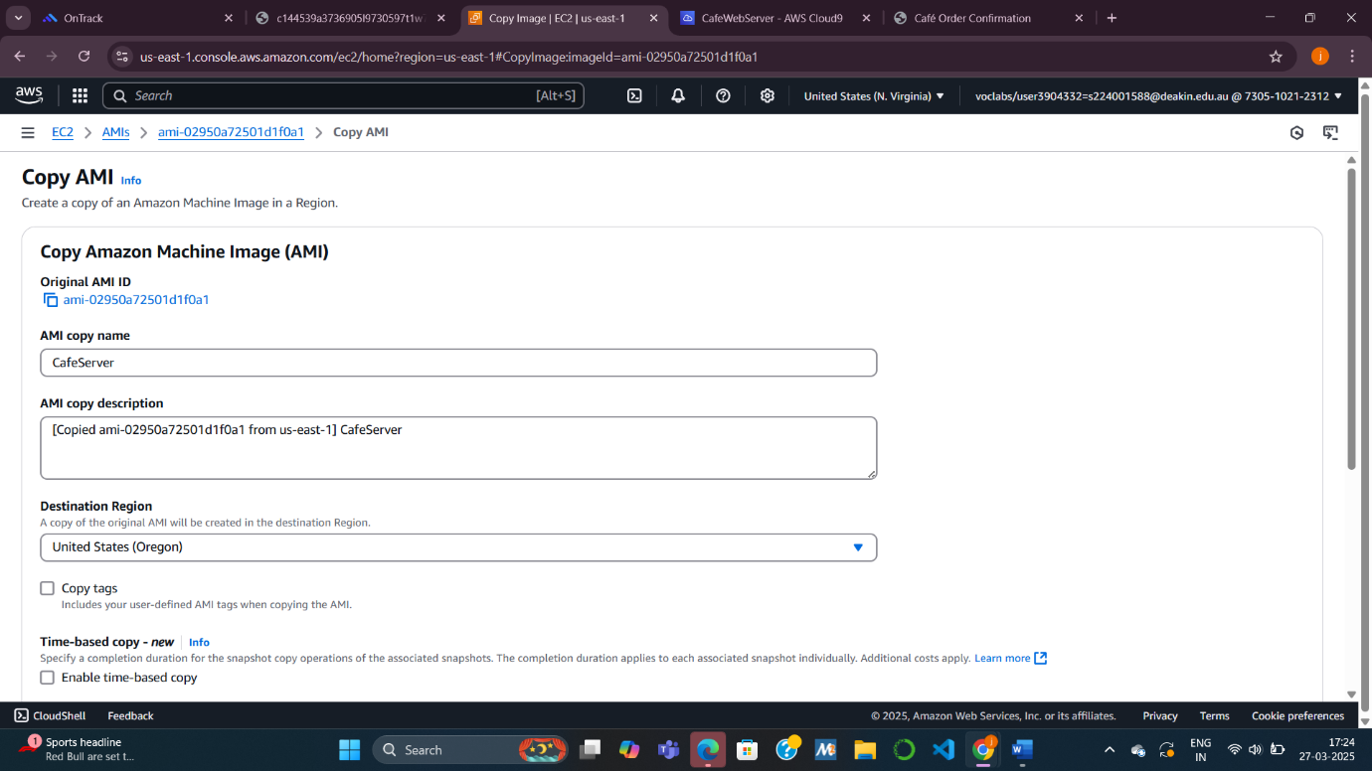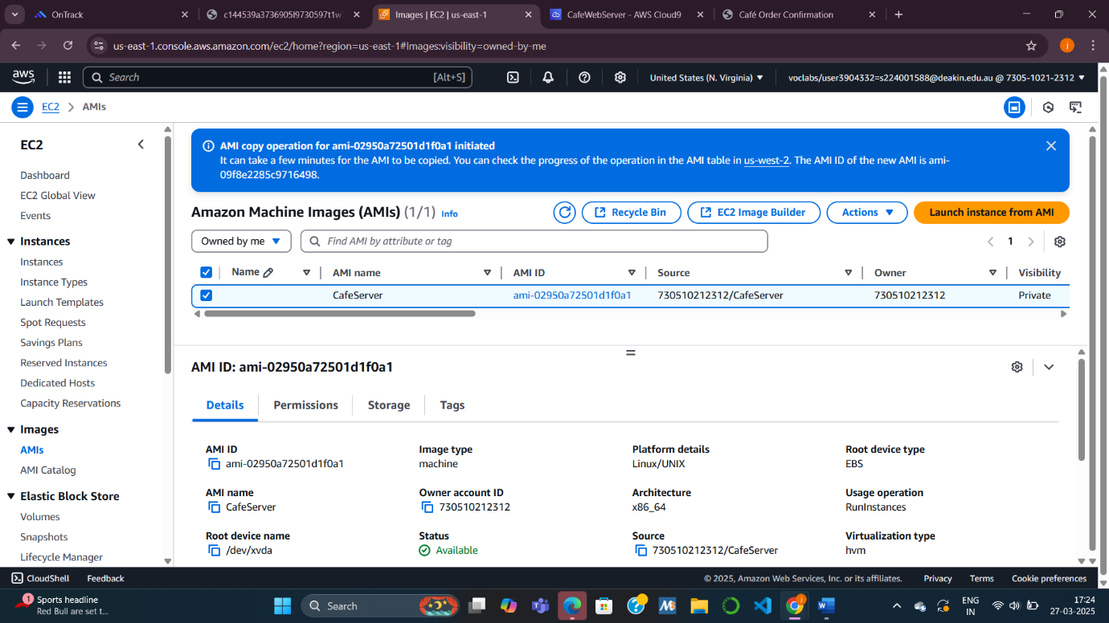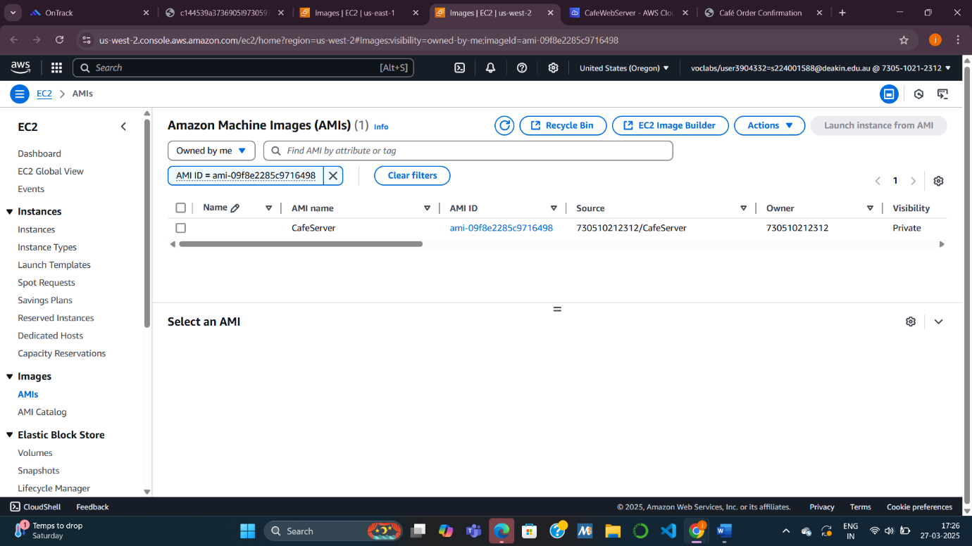

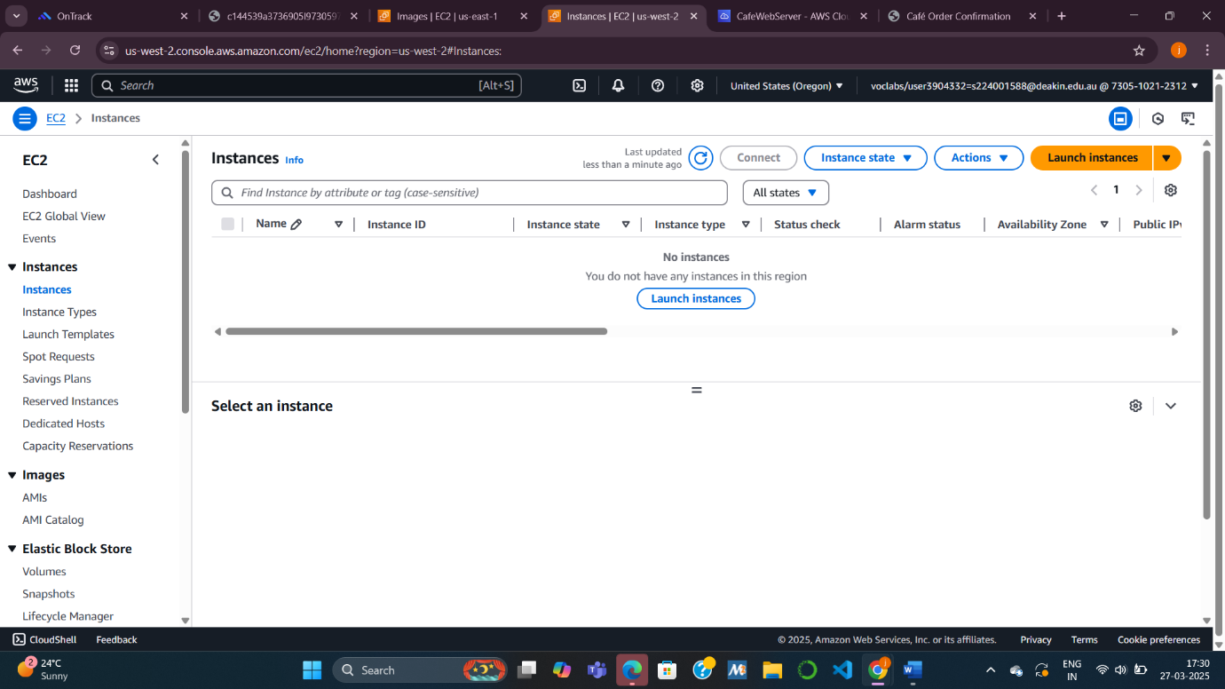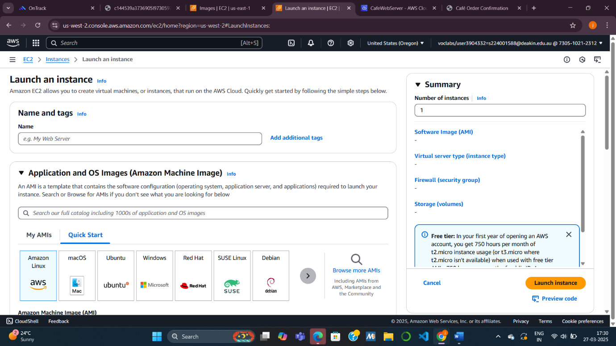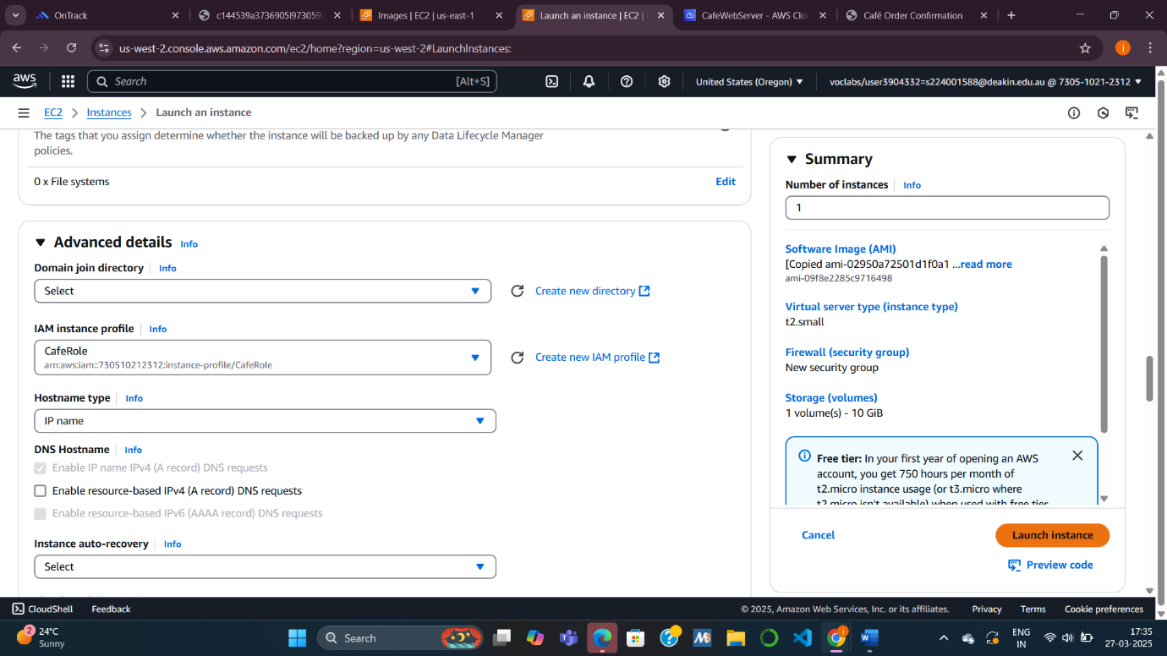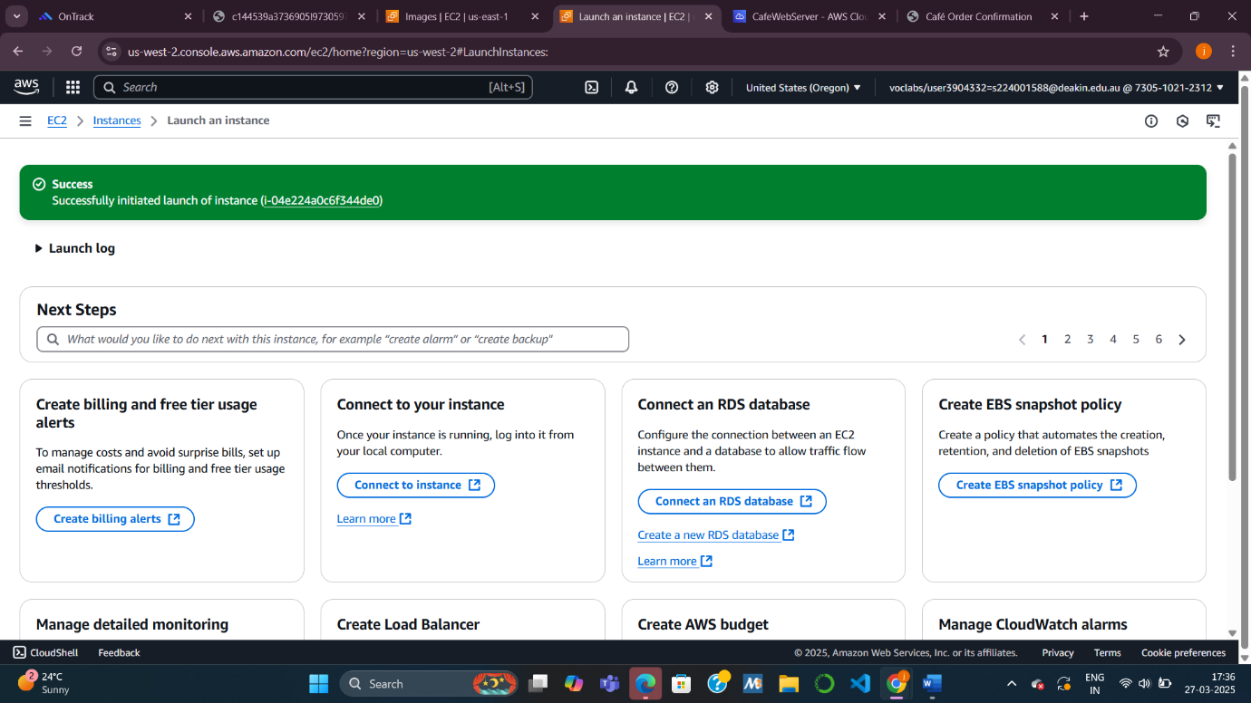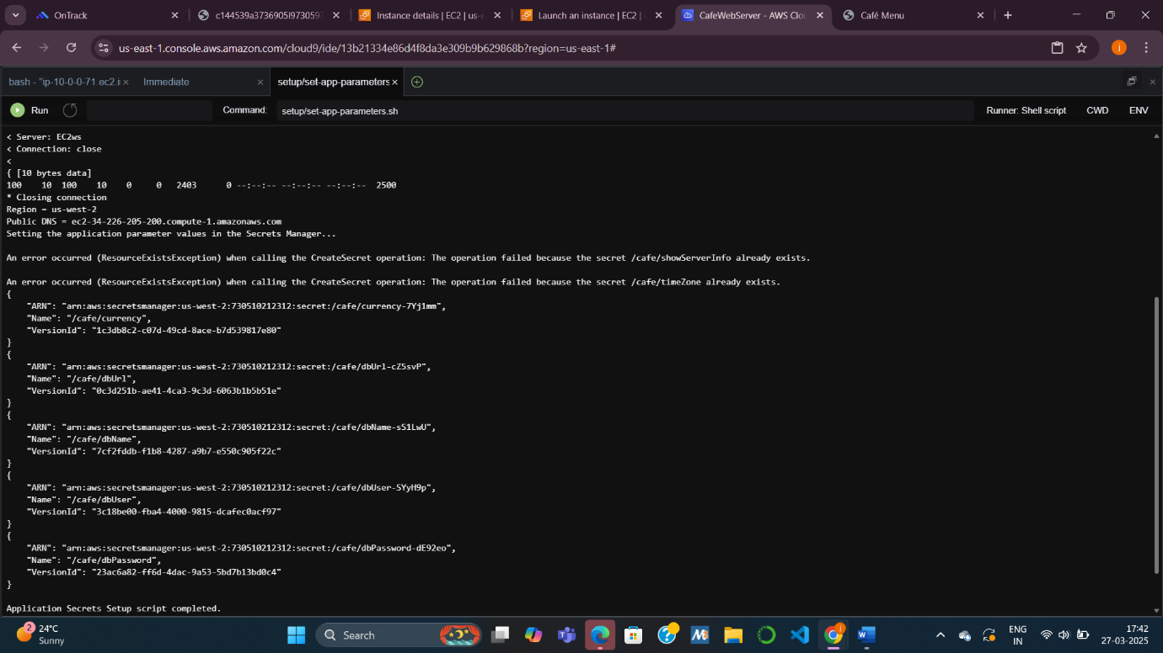

**Task 7: Verifying the new café instance**

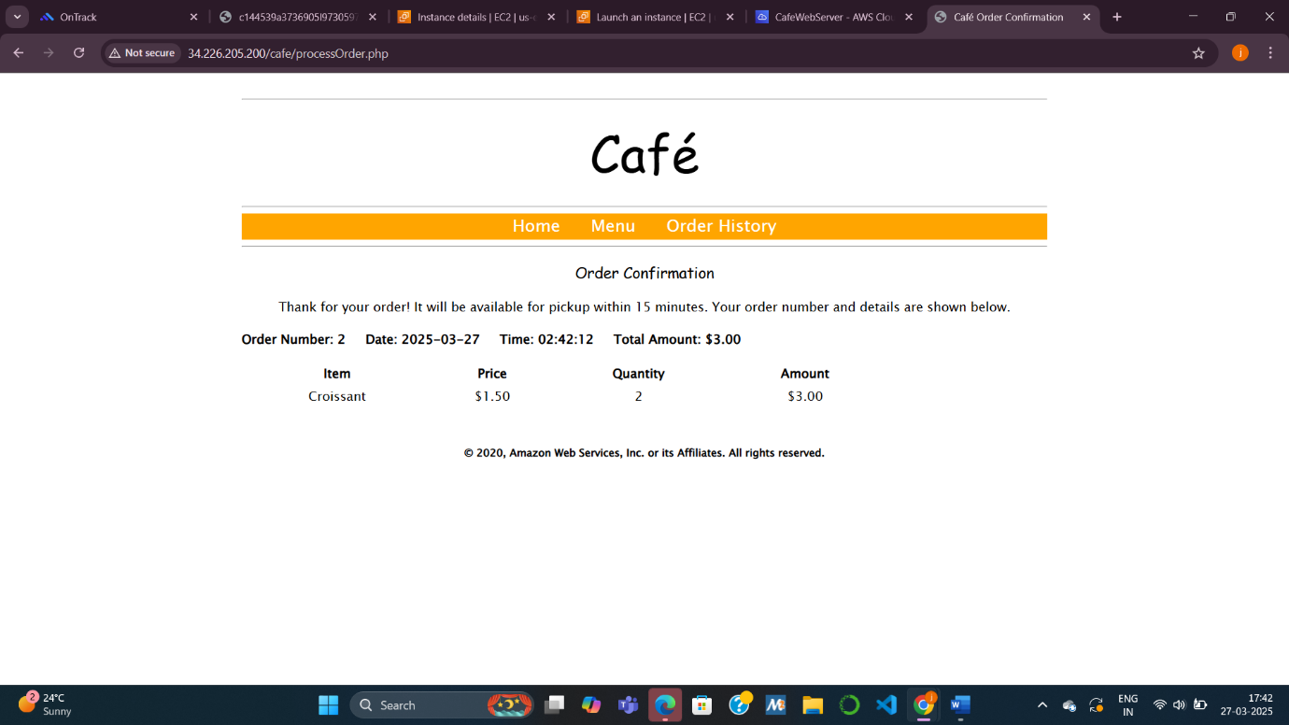

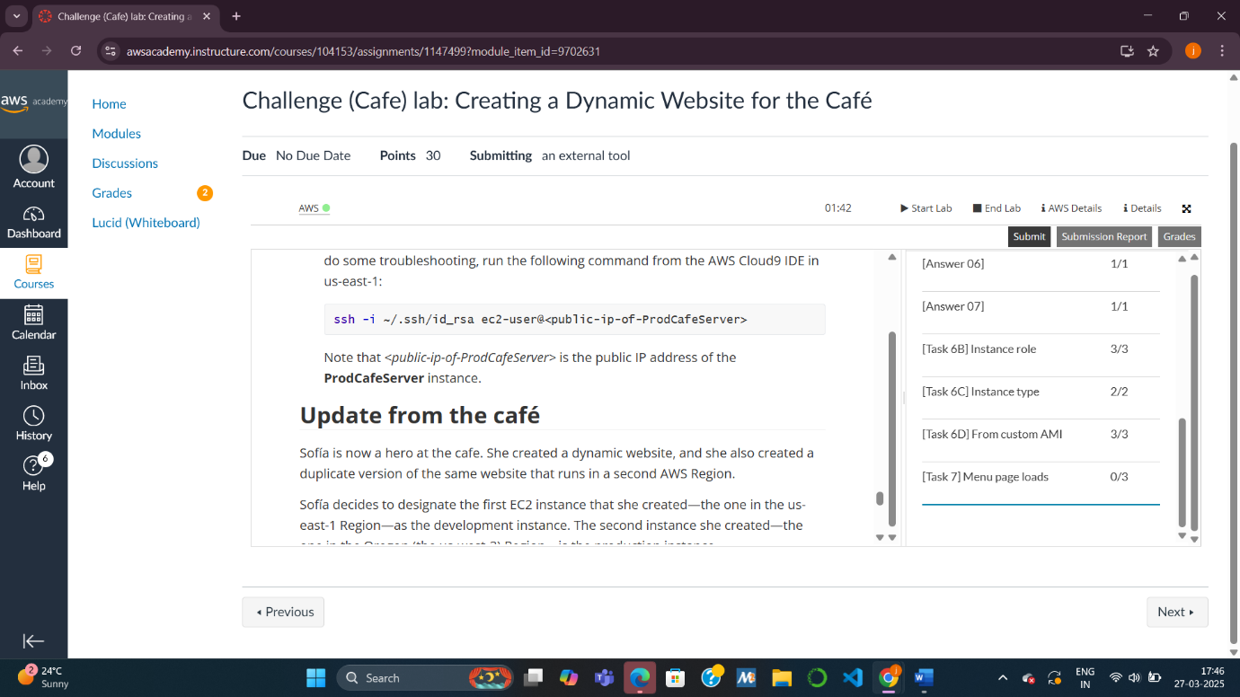

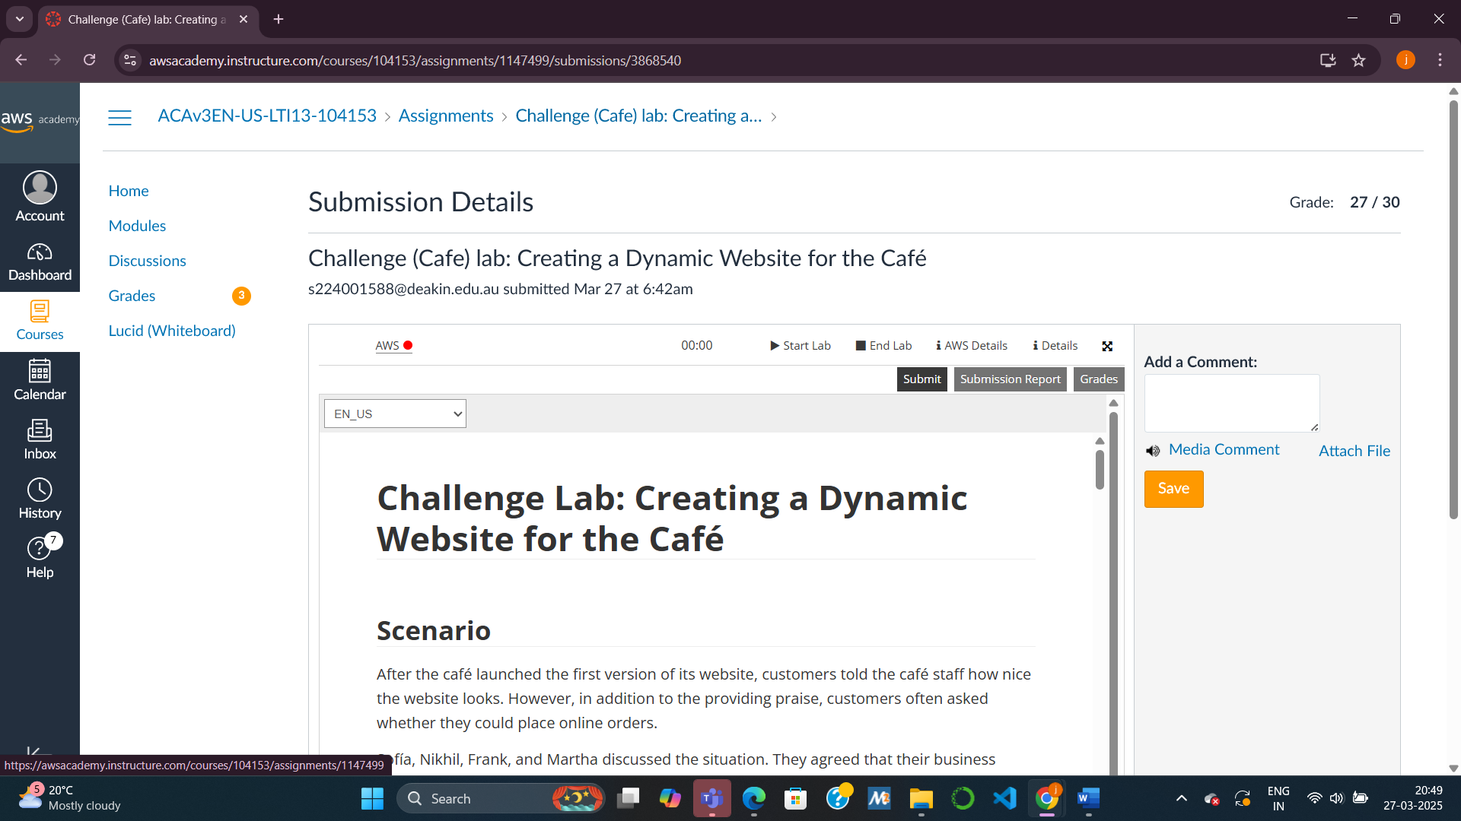

Questions about the instance:

. Is the instance in a public subnet?

Answer: Yes, if we can visit the café’s website from your phone, it’s in a public subnet—like a shop with a street-facing door.  
Example: Think of a café on Main Street; anyone can walk in because it’s “public.”

. Does the EC2 instance have an IPv4 public IP address assigned to it?

Answer: Yes, it has a public IP—like a phone number strangers can call.  
Example: our home Wi-Fi has a public IP so you can browse the internet.

. What inbound TCP port numbers are open for this instance?

Answer: Likely 80 (web), 443 (secure web), and 22 (remote access)—these are like open doors for customers and staff.

Example: Port 80 is like the café’s front door for orders; 22 is the back door for the manager.

. Does the EC2 instance have an AWS Identity and Access Management (IAM) role

Answer: Yes, it probably has an IAM role to fetch secret info—like a staff ID card.  
Example: A cashier needs a key to open the register; the IAM role is that key for the app.

Questions about AMIs

1. When you create an AMI from an instance, will the instance be rebooted?

AWS does not reboot the instance unless you explicitly choose the “No reboot” option and it’s not supported for the instance type. However, in most cases, AWS performs a reboot to ensure a consistent state of the instance’s file system during the AMI creation process. In the lab, unless specified otherwise, assume the instance is rebooted. You can check this in the “Create Image” settings in the EC2 Console – the default is “Reboot.”

1. In what ways can you modify the root volume properties when you create an AMI from an instance?

When creating an AMI, we can modify the root volume properties in the following ways:

* Volume Type: Change the storage type (e.g., from General Purpose SSD gp2/gp3 to Provisioned IOPS SSD io1/io2).
* Size: Increase the size of the root volume (you cannot decrease it below the original size).
* Delete on Termination: Specify whether the volume is deleted when an instance launched from the AMI is terminated (default is typically “Yes”).
* Encryption: Enable or modify encryption settings (e.g., use a specific KMS key).  
  These options are available in the “Create Image” dialog under “Block Device Mappings” in the EC2 Console.

1. Can you add more volumes to an AMI that you create from an instance that only has one volume?

Yes, you can add more volumes to an AMI during its creation. In the “Create Image” process, under “Block Device Mappings,” you can add additional EBS volumes beyond the root volume. For example, you could add a second volume for data storage. These additional volumes will be included in the AMI and attached to any new instances launched from it. However, the original instance itself isn’t modified – the additional volumes are part of the AMI configuration.